# VISVESVARAYA TECHNOLOGICAL UNIVERSITY

### “Jnana Sangama”, Belagavi – 590 018



**Full Stack Web Development (21ADS62)**

**Assignment**

**“*Weather Application*”**

*Submitted By*

|  |  |
| --- | --- |
| CHARAN RK **VAISHNAVI M** | 1GA21AD014 **1GA21AD056** |
|  |  |

Under the Guidance of

**Mr. Shyam Sundar Bhushan**

Assistant Professor

Dept. of CSE

## Image result for GLOBAL ACADEMY OF TECHNOLOGY LOGODepartment of Artificial Intelligence & Data Science

**GLOBAL ACADEMY OF TECHNOLOGY**

### Rajarajeshwarinagar, Bengaluru – 560 098

**2024 - 2025**

**CHAPTER 1**

## PROBLEM DEFINITION

**Introduction:** In today's fast-paced world, access to real-time and accurate weather information is crucial for daily planning and decision-making. Weather conditions can significantly impact various aspects of life, from commuting and travel to outdoor activities and event planning. However, many existing weather information sources are either cumbersome to use, lacking in user-friendly interfaces, or fail to provide localized and timely updates.

**Objective of the Weather Application:** The objective of this Weather Application is to provide users with a seamless, intuitive platform that delivers real-time, localized weather updates. The application aims to address the need for a user-friendly interface that offers accurate and timely weather information tailored to the user's location. By enhancing the accessibility and relevance of weather data, the application seeks to improve daily planning and increase user safety and convenience.

# CHAPTER 2

**IMPLEMENTATION**

**2.1 COMPONENTS**

1. **Weather Component (Weather.js):**

* **Fetches Weather Data:** The code fetches weather data from the OpenWeatherMap API based on the city name input by the user.
* **Maps Weather Icons:** It maps weather condition codes to specific icons, displaying an appropriate weather icon for the current conditions.
* **Displays Weather Information:** The application displays the fetched weather information, including temperature, location, humidity, and wind speed.
* **Search Functionality:** Users can search for the weather in different cities by entering a city name and clicking the search icon.
* **Default City Weather:** The application automatically displays weather data for "Bengaluru" when it first loads.

1. **Styling (Weather.css):**

* **Centering and Styling the Weather Component:** The .weather class centers the weather component on the page, applies padding, and adds a semi-transparent background with a blur effect, giving it a modern, frosted-glass appearance.
* **Search Bar Design**: The .search-bar class styles the search input field and search icon, making them visually appealing with rounded corners, a clean background, and spacing between elements.
* **Weather Icon and Temperature Display:** The .weather-icon class controls the size and margin of the weather icon, while .temperature styles the temperature text with a large, white font for easy readability.
* **Location and Weather Data Layout**: The .location class styles the location name with a large, white font, and .weather-data lays out the weather details (humidity, wind speed) in a row, spaced evenly across the component.
* **Detail Styling for Weather Data:** The .col class organizes the weather data items (e.g., humidity, wind speed) with consistent spacing, icon size, and text formatting, ensuring a clean and organized presentation.

**2.2 PROGRAM CODE**

**JS Code.**

* **Weather.jsx**

import React, { useEffect, useRef, useState } from 'react'

import './Weather.css'

import search_icon from '../assets/search.png'

import clear_icon from '../assets/clear.png'

import cloud_icon from '../assets/cloud.png'

import drizzle_icon from '../assets/drizzle.png'

import rain_icon from '../assets/rain.png'

import snow_icon from '../assets/snow.png'

import wind_icon from '../assets/wind.png'

import humidity_icon from '../assets/humidity.png'

const Weather = () => {

    const inputRef = useRef()

    const [weatherData, setWeatherData] = useState(false);

    const allIcons = {

        "01d":clear_icon,

        "01n":clear_icon,

        "02d":cloud_icon,

        "02n":cloud_icon,

        "03d":cloud_icon,

        "03n":cloud_icon,

        "04d":drizzle_icon,

        "04n":drizzle_icon,

        "09d":rain_icon,

        "09n":rain_icon,

        "10d":rain_icon,

        "10n":rain_icon,

        "13d":snow_icon,

        "13n":snow_icon,

    }

    const search = async (city)=>{

        if(city === ""){

            alert("Enter City Name");

            return;

        }

        try{

            const url = `https://api.openweathermap.org/data/2.5/weather?q=${city}&units=metric&appid=${import.meta.env.VITE_APP_ID}`;

            const response = await fetch(url);

            const data = await response.json();

            if(!response.ok){

                alert(data.message);

                return;

            }

            console.log(data);

            const icon = allIcons[data.weather[0].icon] || clear_icon;

            setWeatherData({

                humidity:data.main.humidity,

                windSpeed:data.wind.speed,

                temperature:Math.floor(data.main.temp),

                location:data.name,

                icon: icon

            })

        } catch (error){

            setWeatherData(false);

            console.error("Well, this is awkward... Let's correct the API and pretend this never happened.");

        }

    }

    useEffect(()=>{

        search("Bengaluru");

    },[])

  return (

    <div className='weather'>

        <div className="search-bar">

            <input ref={inputRef} type="text" placeholder='Search'/>

            <img src={search_icon} alt="" onClick={()=>search(inputRef.current.value)}/>

        </div>

        {weatherData?<>

        <img src={weatherData.icon} alt=""  className='weather-icon'/>

        <p className='temperature'>{weatherData.temperature}°C</p>

        <p className='location'>{weatherData.location}</p>

        <div className="weather-data">

            <div className="col">

                <img src={humidity_icon} alt="" />

                <div>

                    <p>{weatherData.humidity} %</p>

                    <span>Humidity</span>

                </div>

                <div className="col">

                <img src={wind_icon} alt="" />

                <div>

                    <p>{weatherData.windSpeed} KpH</p>

                    <span>Wind Speed</span>

                </div>

            </div>

            </div>

        </div>

        </>:<></>}

    </div>

  )

}

export default Weather

* **Weather.css**

.pomodoro-timer {

.weather{

    place-self: center;

    padding: 40px;

    border-radius: 10px;

    background-color: #1f1b1b49;

    backdrop-filter: blur(150px);

    display: flex;

    flex-direction: column;

    align-items: center;

}

.search-bar{

    display: flex;

    align-items: center;

    gap: 12px;

}

.search-bar input{

    height: 50px;

   border: none;

   outline: none;

   border-radius: 40px;

   padding-left: 25px;

   color: #626262;

   background: #ebfffc;

   font-size: 18px;

}

.search-bar img{

    width: 50px;

    padding: 15px;

    border-radius: 50%;

    background: #ebfffc;

    cursor: pointer;

}

.weather-icon{

    width: 150px;

    margin: 30px 0;

}

.temperature{

    color: #fff;

    font-size: 80px;

    line-height: 1;

}

.location{

    color: #fff;

    font-size: 40px;

}

.weather-data{

    width: 100%;

    margin-top: 40px;

    color: #fff;

    display: flex;

    justify-content: space-between;

}

.weather-data .col{

    display: flex;

    align-items: flex-start;

    gap: 12px;

    font-size: 22px;

}

.weather-data .col span{

    display: block;

    font-size: 16px;

}

.weather-data .col img{

    width: 50px;

    margin-top: 10px;

}

* **App.jsx**

import React from 'react'

import Weather from './components/Weather'

const App = () => {

  return (

    <div className='app'>

      <Weather/>

    </div>

  )

}

export default App

* **main.jsx**

import { StrictMode } from 'react'

import { createRoot } from 'react-dom/client'

import App from './App.jsx'

import './index.css'

createRoot(document.getElementById('root')).render(

  <StrictMode>

    <App />

  </StrictMode>,

)

**CHAPTER 3**

**SNAPSHOTS**

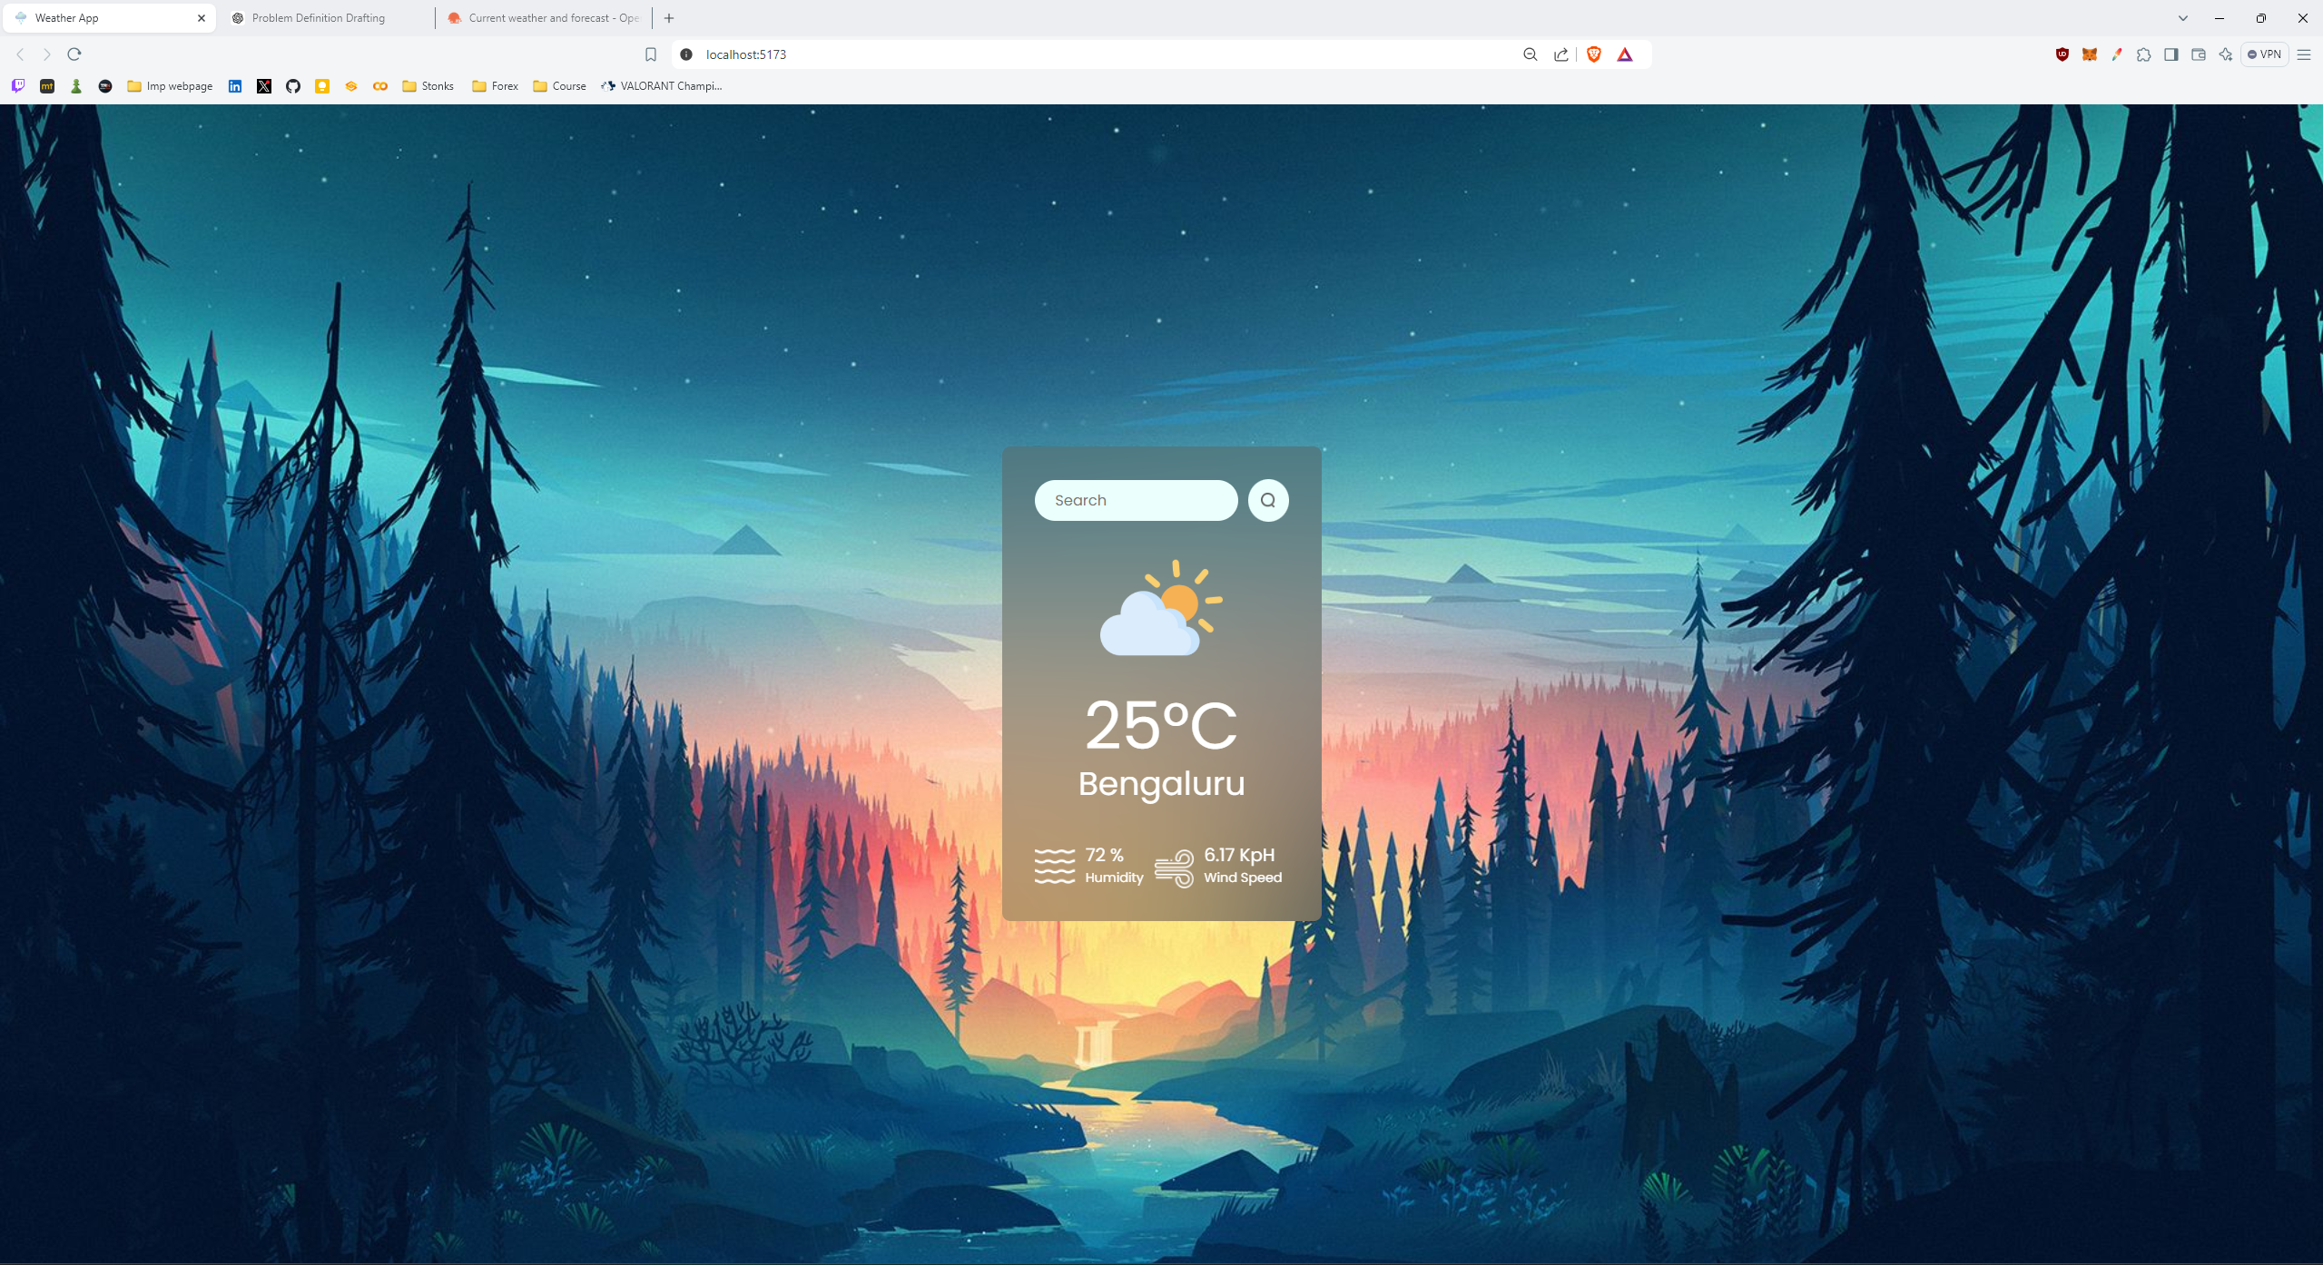

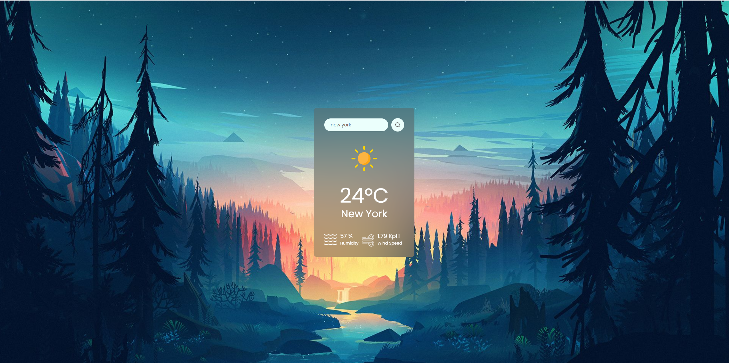

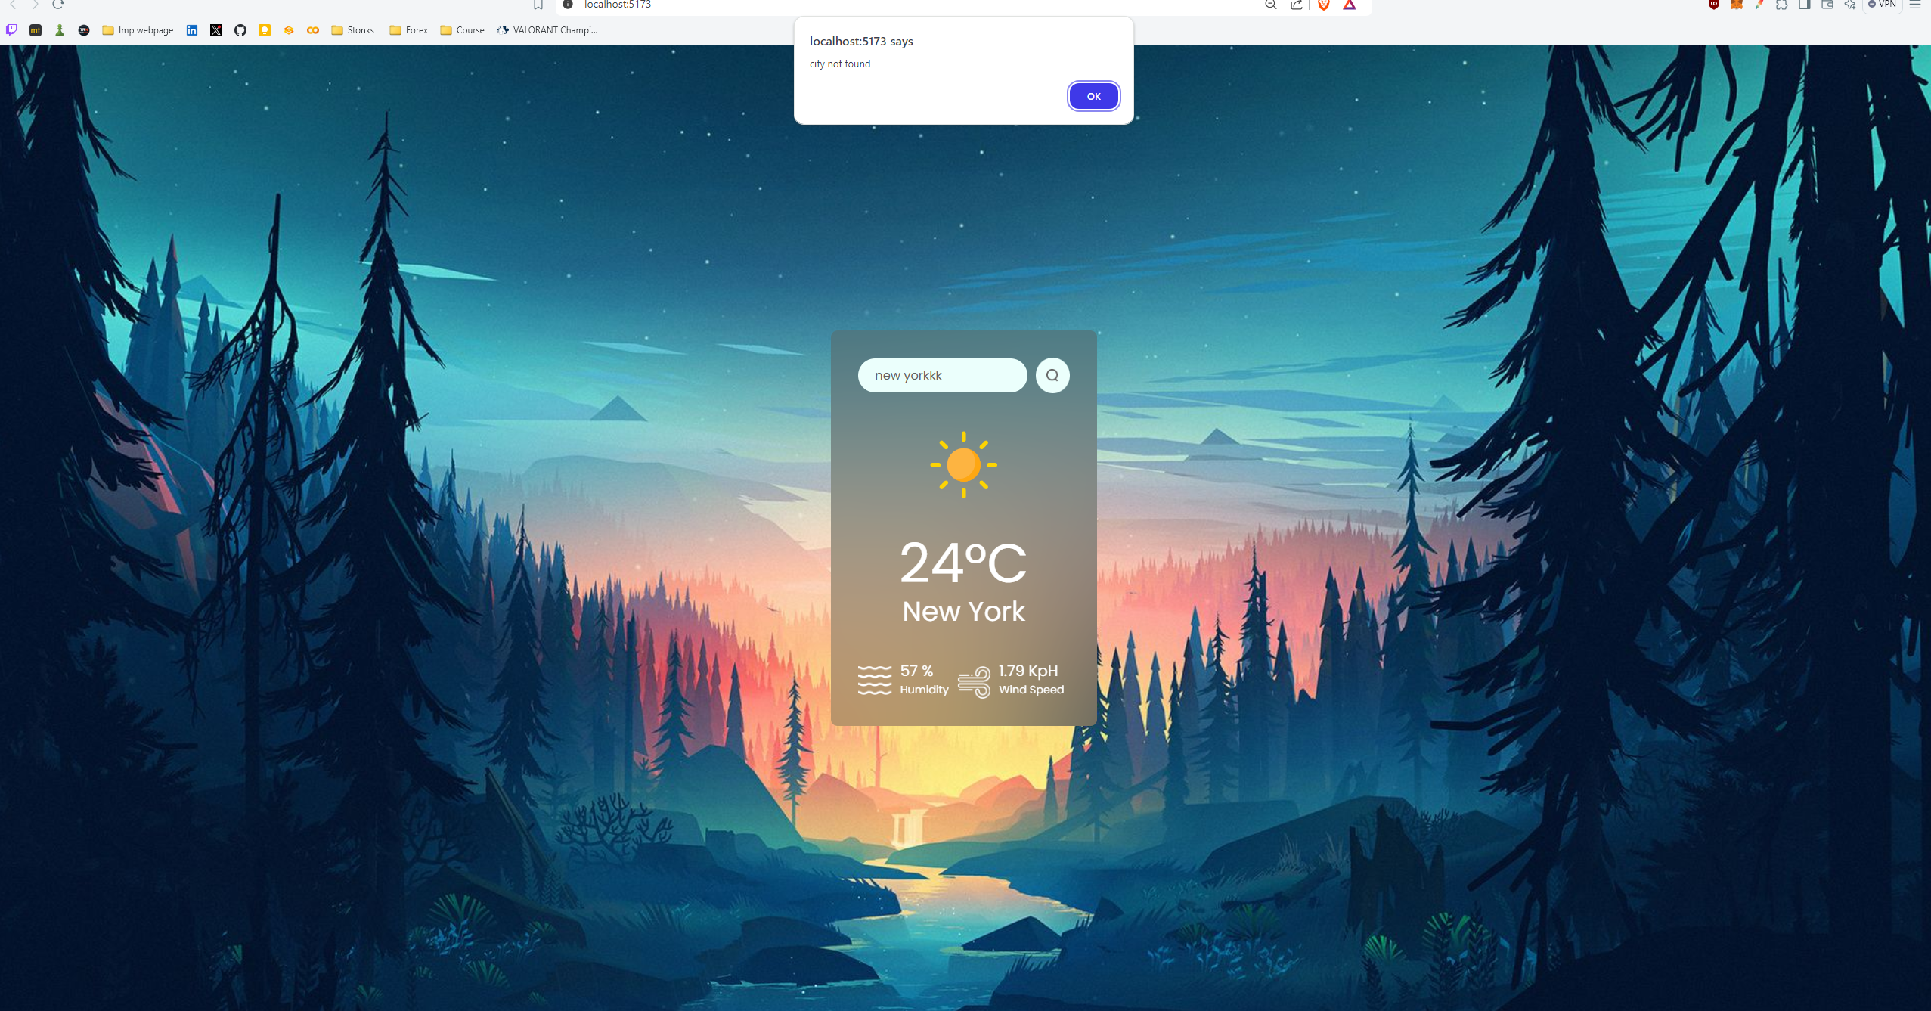

## CONCLUSION

The Weather Application project successfully demonstrates the development of a user-centric tool that provides accurate and real-time weather information. By leveraging React and JavaScript, the application offers a seamless and intuitive interface, allowing users to easily search for and access weather data specific to their location or any city of interest.

The integration of the OpenWeatherMap API ensures that the data displayed is both current and reliable, enhancing the user experience. The application’s design, featuring clear and relevant icons, improves accessibility and ensures that users can quickly understand the weather conditions immediately.